Where is Dumbo?
He is praying to god in …..
He is waiting for a train at the …….
He is entertaining himself in the …..
He is borrowing a book from the ….
He is watching some ships and boats in the ….
He is enjoying the performance in the …..
He is looking at some animals in the ….
He is afraid of heights but he is standing on the top of the …..
He wants to report a crime at the …..
He is buying some sports equipment in the ….
He is going for a walk in the …
He is seriously ill, so he is staying in the …..
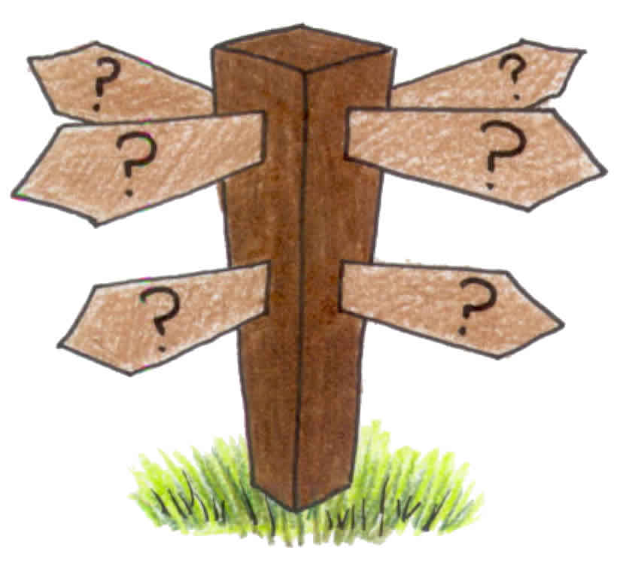
He is withdrawing some money from …..
He is drunk and he is leaning against the ….
He is watching the football match at the ……
He is getting married in ……
He is playing with other children in the …..
His wife kicked him out of the house, so he is spending the night in the ….
He is marvelling at the works of art in the ….
He is filling the car up at the …
He wants to rent a car, so he is going to the …

KEY:
He is praying to god in a church / the cathedral.
He is waiting for a train at the railway station.
He is entertaining himself in the theme park / amusement park.
He is borrowing a book from the library.
He is watching some ships and boats in the harbour.
He is enjoying the performance in the theatre.
He is looking at some animals in the zoo.
He is afraid of heights but he is standing on the top of the …..skyscraper / tower.
He wants to report a crime at the police station.
He is buying some sports equipment in the sports shop.
He is going for a walk in the park.
He is seriously ill, so he is staying in the hospital.
He is withdrawing some money from the ATM
He is drunk and he is leaning against the ….LAMPPOST / WALL.
He is watching the football match at the ……STADIUM / PUB
He is getting married in ……WEDDING CHAPEL / Town Hall.
He is playing with other children in the …..PLAYGROUND.
His wife kicked him out of the house, so he is spending the night in the ….HOTEL / MOTEL
He is marvelling at the works of art in the ART GALLERY.
He is filling the car up at the GAS STATION / PETROL STATION.
He wants to rent a car, so he is going to the CAR RENTAL (AGENCY).

